**FAST TRACK**

**Training Manual 2016**

# INTRODUCTION

**The Manual**

The FastTrack model for the delivery of ART care was designed to improve long-term retention in care by reducing access barriers and enhancing the role of the ART client in the management of his/her condition. The manual should be used to train health workers both at the health facility and in the community on delivery of the FastTrack model. It acts as a guide and reference to facilitators when briefing the different cadres on the FastTrack model of care.

**Course aim**

The three-day course is designed to equip health workers and other staff involved in the FastTrack model with knowledge and skills so that they are able to run the FastTrack model in their various catchment areas.

**Course Objectives**

By the end of the session participants should have knowledge about:

1. Overview of FastTrack Model of Care
2. Communication in FastTrack: Roles and Responsibilities
3. Implementation of FastTrack
4. Preparations to Implement the FastTrack Model

Each topic has been explained and step-by-step activities included for easy follow up of the content.

### **ABBREVIATIONS AND ACRONYMS**

|  |  |  |
| --- | --- | --- |
| ART | : | *Antiretroviral Therapy* |
| HCW | : | *Health Care Worker* |
| LTFU | : | *Lost to Follow Up* |
| M&E | : | *Monitoring and Evaluation* |
| QA/QC | : | *Quality Assurance/Quality Control* |
| SOP | : | *Standard Operating Procedure* |
| VL | : | *Viral load (e.g. VL testing)* |

# MODULE 1: OVERVIEW OF FastTrack MODEL OF CARE

**Time Allocation**: 1 hour 15 minutes

**Purpose:**

This session will provide those involved in the FastTrack model with information about FastTrack and how it will be implemented.

**Learning objectives:**

By the end of this session, participants should be able to:

* Define FastTrack
* Identify the participant criteria to join FastTrack
* List the benefits of the FastTrack model of care

**Suggested Teaching/Learning Methods:**

Interactive games, lecture, discussion, brainstorming

**Suggested Teaching/ Learning Materials:**

Chalk and chalkboard, flip chart papers, permanent markers, transparencies and overhead projectors, audiovisual aids, small prizes (e.g. candy/sweets)

**Teaching and Learning Activities**

## **ACTIVITY 1: Overview of FastTrack (1 hour)**

The facilitator should facilitate the discussion on the definition of FastTrack, benefits, and criteria to join the model.

FastTrack is a model which rapidly distributes ARVs to stable patients using abbreviated adherence counseling from a special FastTrack room or unit. FastTrack participants receive a short symptom screening from a Lay Healthcare Worker and a three-month drug supply from a Pharmacy Technologist each time they come for a pharmacy pick-up. Every other visit (i.e. every sixth month), participants also have a clinical visit at the health facility. The purpose of FastTrack is to give stable, adherent patients their ARVs quickly, so that they do not have to spend time sitting in queues.

**Criteria to join FastTrack**

The following criteria must be met for an individual to be eligible to join FastTrack:

**Inclusion criteria:**

* HIV-positive adolescents and adults (> 14 years of age)
* Last CD4 count (obtained within the last six months) > 200
* Not acutely ill
* On ART for at least 6 months

**Exclusion criteria:**

* Pregnancy
* Unwilling to participate in FastTrack

**Goal of FastTrack**

The objectives of the FastTrack model of care are to reduce the workload of the health workers in the health facilities and to improve patients’ long-term retention in care by reducing access barriers.

**Why FastTrack?**

Many stable, adherent patients face difficulties in continuing ART due to reasons such as:

* Long wait times at the health facility
* Frequent visits to the health facility to pick up ARVs
* Other competing activities (work, social, family) which prevent the patient from spending long periods of time and/or multiple days each year at the facility

**Benefits of FastTrack**

***Benefits to FastTrack members***

* Facilitates faster ARV refills
* Decreases frequency of health centre visits, thereby reducing transport cost as well as long waiting times in the queues
* Fewer missed days of work/chores/etc.

***Benefits to the staff at the health facilities***

* Having less frequent and expedited ARV pick-ups means that the daily workload for the health workers is decreased. He/she will have more time for the individual care of patients who are ill and need more attention.

**How is the FastTrack model implemented?**

## **ACTIVITY 2: Knowledge Check Game (15 minutes)**

The facilitator will ask the following questions to the group. The first person to raise their hand and answer the question correctly will get a prize.

* What is the CD4 count cutoff for someone to be eligible for FastTrack?
* How long must someone be on ART before they are eligible to join FastTrack?
* What’s an example of something that would prevent someone from being able to join FastTrack?
* Name two benefits to the client for being in FastTrack
* Name a benefit to the staff at health facilities when patients are in FastTrack

# MODULE 2: COMMUNICATION IN FastTrack MODEL OF CARE: ROLES AND RESPONSIBILITIES

**Time Allocation: 1 hour 15 minutes**

**Purpose:**

This session introduces and enables participants to acquire knowledge on how to communicate effectively within the FastTrack model of care. Additionally, participants will understand the roles and responsibilities of FastTrack staff and model participants.

**Learning Objectives:**

By the end of this session, participants should be able to:

▪ Define communication

▪ State the importance of communication in the FastTrack model of care

▪ Describe the communication flow in the FastTrack model of care

▪ State the roles of different cadres regarding communication in FastTrack model of care

**Suggested teaching/learning methods:** Lecture, discussion, brainstorming, demonstration, role play

**Suggested teaching and learning materials:**

Chalk and chalkboard, flip chart papers, permanent markers, transparencies, overhead projector, audio-visual aids, and small prizes (e.g. candy/sweets)

**______________________________________________________________________________**

**Teaching and Learning Activities**

## **ACTIVITY 1: What is Communication? (15 minutes)**

The facilitator should lead a discussion on how to define communication and the importance of communication in the FastTrack model of care using the information below.

**Definition of communication**

Communication is a process through which messages/ideas are expressed from one person to another person(s). The messages can be in the form of information, instruction, thoughts, feelings, signals or activities. Communication is most effective when it is a two-way process and all involved can speak and respond without interruption.

The overall aim of communication is to enable the sender to send his/her message to another individual(s) in a clear and effective manner.

In the FastTrack model of care this means the ability of a staff member to effectively transmit information, instructions, guidance, advice, feelings, or thoughts to other staff and health worker or to FastTrack clients. For the client who joins FastTrack, this means the ability to effectively transmit information, feelings, or thoughts to other health workers at the facility.

**Importance of communication**

The major purpose of communication in the FastTrack model of care is to ensure a high quality of care for clients on ART and to enhance the role of the ART client in the management of his/her own condition. For FastTrack to work well, there needs to be good communication.

The main goals of communication for the pharmacy technologist are to:

* Provide support and supervision of the lay HCW in his/her duties
* Ensure that the health facility leadership are aware of key events and challenges encountered when implementing FastTrack

The main goals of communication for the lay healthcare worker are to:

* Provide support to FastTrack clients
* Ensure that the pharmacy technologist is aware of key events and challenges encountered with implementation of FastTrack
* Serve as a liaison between the FastTrack client and the health facility

The main goals of communication for the client are to:

* Establish & maintain relationships with staff at the health facility
* Gather information about their treatment and condition
* Provide information about any side effects or illness
* Self-expression when meeting with staff at the health facility

## **ACTIVITY 2: Communication in the FastTrack Model of Care: Roles and Responsibilities (30 minutes)**

The facilitator will provide participants with the SOP on *FastTrack Roles and Responsibilities* and the FastTrack *Roles and Responsibilities Flowchart*.

The facilitator should first go through the Flowchart so that participants have a general understanding of roles and then proceed to the to the SOP where detailed responsibilities are outlined.

1. **Pharmacy Technologist**

* Conducting enrollment procedures
* Dispensing medications at FastTrack visits and documenting in Smart Care Pharmacy Form
* Supporting and supervising the lay HCW in all their duties
* Alerting the Health Facility In-Charge in the event of a hospitalization or death
* Obtaining dried blood specimen for viral load (VL) testing

**2. Lay Health Care Worker**

* Assisting the pharmacy technologist with enrolling eligible patients
* Maintaining a FastTrack appointment diary
* Pulling and storing FastTrack members’ files prior to a FastTrack visit
* At FastTrack visits, completing the FastTrack attendance register
* Facilitating the up-referral of any FastTrack members who need a clinic visit
* Coordinating with clinic tracing staff to ensure patient tracing as outlined in the SOP
* Alerting the pharmacy technologist in the event of a hospitalization or death of a FastTrack member
* Assisting the pharmacy technologist with viral load testing

**3. Data Associate**

* Enter completed clinical visit and pharmacy forms into Smartcare

**4. Facility QA/QC Overseer**

* Oversee all quality control procedures related to this model

## **ACTIVITY 3: Name Game (30 minutes)**

The purpose of this game is to make sure that everyone clearly understands roles and responsibilities. The facilitator will divide the room into teams of 3 people. The facilitator will then state a specific role/responsibility of an individual involved in the model starting with Team 1 who will identify the title of the person who performs that role/responsibility. If they answer correctly, then they receive a point. If they do not answer correctly, then the facilitator will ask the same question to Team 2 and proceed in this manner. The first team to 5 points wins the game. *If participants are having a difficult time understanding individual roles and responsibilities, the facilitator should review the SOP with the group again.*

# MODULE 3: IMPLEMENTATION OF FastTrack

**Time Allocation: 3 hour 15 minutes**

**Purpose:**

This session enables health care workers to acquire knowledge on how to handle FastTrack.

**Learning objectives:**

By the end of this session, participants should be able to;

* Describe the patient flow at a health facility during a FastTrack visit and a clinical visit with the ART provider
* Define the FastTrack Attendance Register
* Demonstrate how to fill the FastTrack Attendance Register
* Explain what happens if a FastTrack member is ill or pregnant

**Suggested teaching/learning methods:**

Lecture, discussion, brainstorming, exercise, question and answer

**Suggested teaching and learning materials:**

Chalk and chalkboard, flip chart papers, permanent markers, paper and pens, transparencies and overhead projectors, audio visual aids, small prizes (e.g. candy/sweets).

______________________________________________________________________________

**Teaching and Learning Activities**

## **ACTIVITY 1: Model flow (30 minutes)**

The facilitator should explain the FastTrack model flow using the SOP on *FastTrack Roles and Responsibilities* and the *FastTrack Roles and Responsibilities Flowchart*.

**Procedures BEFORE a FastTrack member visit**

FastTrack units will be operational on Monday, Wednesday and Friday. One day prior to the FastTrack visit, the Lay HCW should pull all the FastTrack members’ ART files scheduled for the following day from the registry room and provide them to the Pharmacy Technologist who will prepare and pre-pack medications for all FastTrack members.

**FastTrack member visit:**

On the day of a FastTrack-only visit, the FastTrack member will go straight to the FastTrack room. At the FastTrack room, one of the Lay HCWs will conduct adherence counseling, symptom screening and complete the FastTrack attendance register. The next FastTrack appointment date will be scheduled for 3 months from the current date and will be written in the FastTrack attendance register and in the patient’s ART card by the lay HCW. The Pharmacy Technologist will then dispense the 3-month drug supply and complete the Smart Care Pharmacy Form. On every other FastTrack visit day (every 6 months), the FastTrack member will also have a clinical visit on the same day. On these days, the patient will first go to their clinical visit and then go to the FastTrack room for a routine FastTrack visit to receive their medications.

**Procedures AFTER a FastTrack member visit**

The lay HCW should write the date of the next FastTrack appointment for each patient seen that day in the FastTrack Appointment Diary. If the patient is scheduled to see the ART provider at the next FastTrack visit, this should be indicated by marking a star next to the patient’s name. This will serve as a reminder when the patient returns to clinic for the next FastTrack visit to make sure that they have seen the doctor/provider that day.

## **ACTIVITY 2: Roles and Responsibilities Game (30 minutes)**

The facilitator will ask questions to the group regarding the FastTrack model flow. The first person to raise their hand and answer the question correctly will get a small prize.

**Sample Questions:**

1. Where are the FastTrack Registers kept?
2. Who is responsible for pulling patient files before a FastTrack visit?
3. Who is responsible for pre-packing medications?
4. Who is responsible for completing the FastTrack Attendance Register during a FastTrack visit?
5. Who is responsible for assigning the next FastTrack visit date and writing it in the patient ART card?
6. How often must the FastTrack member see the ART provider?
7. Who is responsible for escorting the patient to their clinical visit with the ART provider?
8. What steps need to be taken after a FastTrack visit is completed?

## **ACTIVITY 3: The *FastTrack Attendance Register* Form (45 minutes)**

The facilitator should distribute blank copies of the FastTrack Attendance Register and describe the use of the form and the variables on the form.

This form will keep a record of attendance for all FastTrack visits and will assist the lay HCW in completing a brief symptom screen. It is the responsibility of the lay HCW to fill out the *FastTrack Attendance Register* during FastTrack visits*.*

The attendance register has the following variables:

* Clinic name
* Date of FastTrack visit
* ART ID Number
* Patient first name and last name
* Pregnant (Y/N)
* Feel ill? (Y/N)
* If you feel ill, have you experienced any of the following in the past week?
  + Fever (Y/N)
  + Night sweats (Y/N)
  + Weight loss (Y/N)
  + Cough (Y/N)
  + Severe headache (Y/N)
  + Other
* Date of next FastTrack visit
* Referred to clinic (Y/N)

Note: The date of *next FastTrack* visit should be 3 months from the current FastTrack visit date.

*Note:* ***A patient should be referred to clinic for a facility visit if they are ill, pregnant, or no longer want to be in FastTrack.***

Before ending this session, provide 10 minutes for training participants to practice filling out this form. The facilitator can pretend to be the FastTrack member visiting the clinic. The participants should ask the facilitator the information needed to complete the form: i.e. What is today’s date? What is their name and ART ID? Are they pregnant? Are they feeling ill? Etc.

## **ACTIVITY 4: Handling Specific Situations (30 minutes)**

The facilitator should explain the procedures that should be followed if any of the following situations occur.

* **Missing FastTrack member:** If a FastTrack membermisses a visit and has not collected their medicine within five working days, the lay HCW will add the name of the patient to the LTFU list at the facility and will be traced according to current clinic procedures.
* **Ill FastTrack member:** In the event that a FastTrack member is identified as being ill, the lay HCW will facilitate a clinic visit by escorting the patient over to the clinic.

*Note: All* FastTrack *members should be encouraged to contact the lay HCW at any time directly if they are ill and need a facility visit.*

* **Pregnant FastTrack member:** In the event that a FastTrack member is identified as being pregnant, the lay HCW will facilitate a clinic visit by escorting the patient to the Maternal and Child Health Department
* **FastTrack member who no longer wants to be in FastTrack:** Lay HCW will facilitate a clinic visit with the ART In-Charge so that patient may return to regular facility care

## **ACTIVITY 5: Mock FastTrack Visits Role Play (1 hour)**

The facilitator will divide the participants into groups of 3 and hand out member roles on pieces of paper. One person will be lay HCW 1 (completing the Attendance Register), another person will be lay HCW 2 (responsible for escorting patients as necessary to ART provider), another person will be the Pharmacy Technologist, and the facilitator will be the FastTrack member.

***Example Scenarios that can be used during the training:***

* Female 29, missing from today’s FastTrack visit without having notified anyone
* Male 38, no longer wants to be in FastTrack
* Female 38, feeling well but pregnant
* Female 23, feeling well but coming for FastTrack visit on a day that FastTrack services are not offered
* Male, 27, feeling unwell, has a headache and has had night sweats the past week

# MODULE 4: PREPARATIONS TO IMPLEMENT THE FastTrack MODEL

**Time Allocation: 2 hours**

**Purpose:**

This session enables participants to understand the preparations and procedures for implementing the FastTrack model at their site.

**Learning objectives:**

By the end of this session, participants should be able to;

* Understand the recruitment and enrollment procedures for the FastTrack model

**Suggested Teaching/Learning Methods:** Lecture, discussion, brainstorming, question and

answer, exercise

**Suggested Teaching/Learning Materials:** Chalk and chalkboard, flip chart papers, permanent markers, pens and papers, transparencies and overhead projectors, audiovisual aids, small prizes (e.g. candy/sweets).

______________________________________________________________________________

**Teaching and Learning Activities**

## **ACTIVITY 1: Overview of Participant Recruitment and Enrolment (1 hour 15 minutes)**

The facilitator will begin by explaining that, like many healthcare services, it is important that within the FastTrack model appropriate procedures are taken to ensure that safety and ethics are upheld for both staff and patients.

*Participants have already had modules 1-3 and should therefore have a good understanding of what the FastTrack model is and how it operates within the facility. This module is specific to explaining how recruitment and enrollment procedures will operate at the selected sites.*

The facilitator will pass out the *FastTrack Enrolment Flowchart,* and the *FastTrack Enrolment SOP* to utilise during this module and then proceed with explaining how patients will be recruited and enrolled. Later in this activity, the facilitator will review the *Viral Load Log Book* and the *FastTrack Enrolment Register*.

The facilitator should begin by noting that the next five steps that will be reviewed correspond to the five steps outlined in the FastTrack Enrolment SOP. They should also be encouraged to write these numbers down on the different areas of the Flowchart.

**1. How will eligible patients be identified?**

Patients will be recruited every day of the work week (Monday-Friday). Patients attending the clinic for a visit with the doctor should be approached for enrolment into FastTrack. During the clinical consultation, the doctor will review the patient’s chart to determine if the patient meets the eligibility criteria for FastTrack.

For patients who are unsure of their pregnancy status, they ought to be offered the opportunity to take a pregnancy test by the clinician to further determine eligibility.

If eligibility criteria are met, then the Clinician will direct the patient to the waiting lay HCW at the end of the clinical visit. The lay HCW will then briefly informs the patient that they have been invited to participate in a program that could make getting ARVs easier for the patient. If the patient is interested, then the lay HCW will take him/her to the Pharmacy Technologist in the FastTrack room, who will discuss the FastTrack program in full detail.

**2. How will eligible patients be recruited into FastTrack care?**

The Pharmacy Technologist will use the FastTrack Infographic to explain the FastTrack model to the patient. After going through the Infographic and answering any questions, the patient will be asked if they are interested in joining FastTrack. The facilitator should explain that patients should willingly choose to participate in FastTrack.

**3. Obtaining dried blood spot (DBS) specimen for viral load testing**

After agreeing to participate in FastTrack, dried blood samples should be collected for viral load testing by the Pharmacy Technologist or lay HCW according to the *SOP 2.7 DBS Collection and Handling*. Each specimen collected will be recorded in the Viral Load Log Book. The Facilitator should direct the participants to the Viral Load Log Book in their training manual and note that there will be a separate special training on how to collect dried blood spots later.

**4. Filling out the FastTrack Enrolment register**

As each patient is enrolled, add their information to the FastTrack enrolment register for that group.

1. The column “Enrolment number” should be numbered sequentially from 1 to 400. The first row should be 1, the second row should be 2, and so on. This is helpful in M&E activities for tracking enrolment numbers over time.
2. List the ART ID and First Name, Last Name.
3. In the next several columns, list the patient’s: Sex, Date of Birth, Mobile phone 1, Mobile phone 2.
4. For “Date joined FastTrack”, write the date of FastTrack enrolment for that patient.
5. For “Date of first FastTrack Appointment”, write the date three months from the date of FastTrack enrolment for that patient.
6. Develop a schedule of all FastTrack member clinic visits to the facility. Clinic Visit 1 should be six months from the patient’s date of FastTrack enrolment. Clinic Visit 2 should be six months after Clinic Visit 1.
7. Update the next appointment date in the clinical form in the patient’s ART file. The next clinical appointment date in the clinical form should be Clinic Visit 1.

**5. Completion of FastTrack Enrolment**

The patient’s new appointment dates (every 3 months) should be written on their ART card and in the FastTrack Appointment Diary. The patient should proceed to the FastTrack pharmacist to receive a three-month drug supply. The next pharmacy and FastTrack visit appointment dates should be the same. The patient’s ART file should then be transferred to the data associate for entry into Smart Care.

## **ACTIVITY 2: Review of Steps and Matching Game (30 minutes)**

The facilitator should remind the group that there were five steps discussed in the previous activity. S/He will write up at the front of the room five blank lines and invite the group to help indicate these steps and their appropriate order.

1. Identifying eligible clients
2. Recruiting/explaining FastTrack to eligible clients
3. Dried blood spot testing
4. Filling out the FastTrack Enrolment Register
5. Completion of FastTrack enrolment

Next, the facilitator should ask the training participants to indicate which form is associated with each step.

1. Identifying eligible clients: none
2. Recruiting/explaining FastTrack to eligible clients: *FastTrack Infographic*
3. Dried blood spot testing: *Viral Load Log Book*
4. Filling out the FastTrack Enrolment Register: *FastTrack Enrolment Register, Clinical Smart Care Form in ART file*
5. Completion of FastTrack Enrolment: patient’s *ART card, FastTrack Appointment Diary*

## **ACTIVITY 3: FastTrack Enrollment Role Play (30 minutes)**

The facilitator will hand out “roles” on pieces of paper so that participants can practice a mock enrollment scenario to make sure that everyone understands how the procedures will be conducted. Roles will include: lay HCW 1, lay HCW 2, pharmacy technologist, and patient. The roleplay will first be done with four training participants at the front of the room and everyone else observing. Then, the entire training group will break up into groups of four and practice the roleplay within the smaller group.

## **ACTIVITY 4: Practice Filling Out the FastTrack Enrollment Register (30 minutes)**

The facilitator should distribute a sample of completed patient information cards and a blank FastTrack Enrollment Register. The participant should then fill out the FastTrack Enrollment Register using the patient information card. The facilitator should review the completed registers to ensure that they were completed correctly. The facilitator should also remind the group that the next step would be to enter those dates into the FastTrack Appointment Diary.

# APPENDICES

1. FastTrack Infographic
2. SOP 2.14 Roles and Responsibilities of FastTrack Personnel
3. FastTrack Model Flowchart
4. SOP 2.3: FastTrack Participant Recruitment and Enrolment
5. FastTrack Enrolment Flowchart
6. FastTrack Enrolment Register
7. FastTrack Attendance Register
8. Comprehension Assessment Form FastTrack
9. SOP 2.7: Dried Blood Spot (DBS) Collection and Handling
10. Viral Load Log Book

## **1.0 FastTrack Infographic**

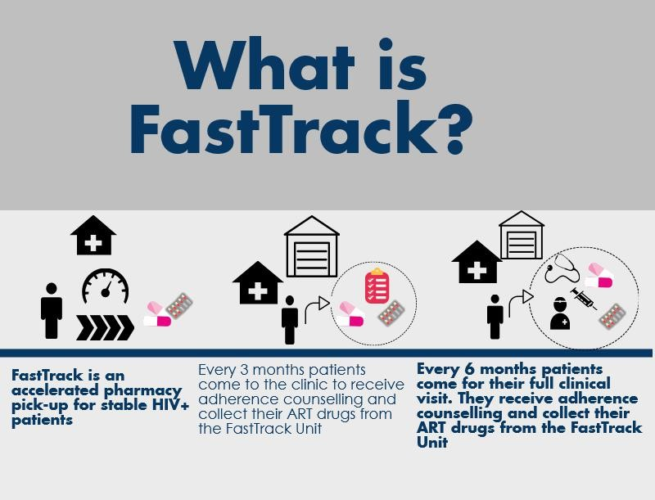

## **2.0. SOP 2.14: Roles and Responsibilities of FastTrack Personnel**

**PURPOSE**

This standard operating procedure (SOP) describes the key roles and responsibilities for all personnel in relation to FastTrack

**SCOPE**

This SOP applies to all personnel involved in the FastTrack model

**MATERIALS**

Patient Card

FastTrack Register Form

FastTrack Attendance Form

FastTrack Appointment Diary

**RESPONSIBILITIES**

* All personnel involved in FastTrack are responsible for adhering to their roles, implementing appropriate procedures, understanding and following this SOP, and following guidelines for the ethical conduct of healthcare service delivery at all times.
* **Pharmacy Technologist** is responsible for
  + Explaining the FastTrack model to the potential participant
  + Enrolling participants into FastTrack
  + Collecting dried blood spot specimens for viral load testing (with help from the lay HCW)
  + Dispensing drugs, entering data on the SmartCare pharmacy form, and accounting for drugs
* **Lay Health Care Worker** is responsible for symptom screening and brief adherence counseling, completing the FastTrack Attendance register, managing referrals to clinic, and referring missing patients to the clinic tracing team
* **Supervisor** is responsible for oversight of FastTrack staff
* **Data Associate** is responsible for entering participant data into Smartcare
* **The QA/QC Overseer i**s responsible for overseeing all quality control procedures related to this model

**PROCEDURES**

Lay Health Care Workers will:

* Review the FastTrack Appointment Diary to prepare files for patients a day before the visit
* Conduct symptom screening and brief adherence counseling using the FastTrack Attendance Register
* Assign the next FastTrack visit appointment (approximately 3 months from the day of the current visit) and indicate this day on the last column of the FastTrack Attendance Register. Also, write this date on the patient’s ART card.
* Escort/direct the patient to the pharmacy technologist to collect their drugs.
* Should need arise during the symptom screening, (patient ill or pregnant) the patients will be referred to the health facility for further management after they collect their drugs
* If a patient continues to require clinical visits at the health facility due to illness, he/she is still eligible to continue receiving drugs via FastTrack.
* In the event that the patient misses their FastTrack visit and does not show up within 5 days of their missed visit, the lay HCW should ensure that this individual be added to the clinic LTFU list so that they can be followed up based on standard of care at the clinic.
* Take the files for those who came through the FastTrack to the data room for data entry into Smartcare.
* After the data has been entered into Smartcare, take files to the registry for filing
* Ensure that the FastTrack member files are stored in separate file space in the registry

Pharmacy technologist will:

* Enroll all eligible clients into FastTrack
  + This includes explaining the FastTrack model to the client, and obtaining agreement from the client to participate
  + Collecting dry blood spot for viral load testing at enrollment and at 12 months post-enrolment (with help from the lay HCW)
* Will review the FastTrack Appointment Diary at least one day before the visit to prepare drugs in advance
* Provide drug adherence counselling
* Dispense drugs for three (3) months to the patient and enter the data onto the SmartCare pharmacy form
* Will also account for the drugs in accordance with MoH guidelines

FastTrack Member:

* Responsible for attending 2 clinical visits, 6 months apart
* Responsible for attending all FastTrack visits every 3 months
* In the event that a FastTrack member is unable to come to their FastTrack appointment, they should inform the Lay HCW so that arrangements for picking up their medication can be made

Data Associate:

* Responsible for entering all SmartCare forms for FastTrack patients into SmartCare once the files are brought back to the Data Room

## **3.0 FastTrack Flow Chart**

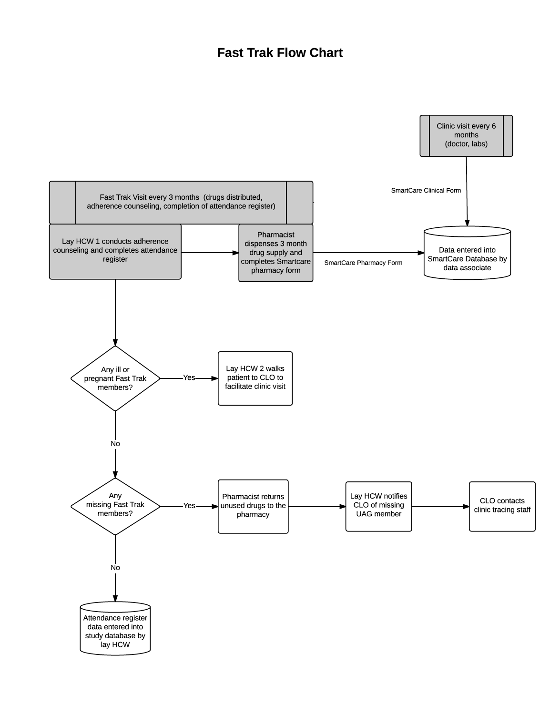

## **4.0 SOP 2.3: FastTrack Participant Recruitment and Enrolment**

**PURPOSE**

This standard operating procedure (SOP) describes the procedures for the recruitment and enrolment of participants into FastTrack.

**SCOPE**

This SOP applies to all personnel involved in the FastTrack model.

**MATERIALS**

FastTrack Enrolment Register

FastTrack Appointment Diary

FastTrack Infographic

**ROLES and RESPONSIBILITIES**

**Pharmacy Technologist** is rresponsible for:

* Conducting enrolment procedures
* Generating the initial FastTrack membership register including the clinic visit schedule

**Lay Health Care Worker** is responsible for:

* Assisting the Pharmacy Technologist with enrolment procedures

**QA/QC Overseer i**s responsible for:

* Overseeing all quality control procedures related to this model (please refer to SOP 3.5: Quality Assurance/Quality Control).

**PROCEDURES (See FastTrack Enrolment Flowchart)**

**1. Identification of individuals to approach for recruitment**

Patients attending the clinic for a visit with the doctor/ clinical officer will be approached for enrolment into FastTrack. During their clinical consultation, the clinician will review the patient’s chart to determine if they meet eligibility criteria for joining FastTrack.

Inclusion criteria:

* HIV-positive adolescents and adults (> 14 years of age)
* Last CD4 count (obtained within the last six months) > 200
* Not acutely ill
* On ART for at least 6 months

Exclusion criteria:

* Unwilling to participate in FastTrack
* Pregnancy

If eligibility criteria are met, then the doctor will direct the patient to the waiting lay HCW at the end of the clinical visit.

For patients that answer that they are unsure of their pregnancy status they will be offered the opportunity to take a pregnancy test by the clinician to further determine eligibility.

The lay HCW will briefly inform the patient that they have been invited to participate in a program that makes getting ARV’s easier for the patient. The lay HCW will escort the patient to the room where the Pharmacy Technologist is seated. The Pharmacy Technologist will then initiate a discussion about FastTrack using the Infographic.

**2. Describing the FastTrack Model**

The Pharm Tech will briefly describe the FastTrack model using the FastTrack Model Infographic. After going through the Infographic and answering any questions the patient will be asked if they are interested in joining FastTrack.

**3. Obtaining Dried Blood Spot Specimen for Viral Load testing**

Dried blood sample should be collected for viral load testing by the Pharmacy Technologist and/or the lay HCW. Please refer to SOP 2.7 for detailed procedures on collecting and handling the dried blood spot specimen.

**4. Generating the FastTrack Enrolment register**

As each patient is enrolled, add their information to the FastTrack enrolment register for that group.

Perform only once:

The very first time you fill out the FastTrack enrolment register, fill out the Clinic Name at the top of the form.

Perform each time you add a patient to the enrolment register:

1. The column “Enrolment number” should be numbered sequentially starting from 1. The first row should be 1, the second row should be 2, and so on. This will be helpful in M&E activities for tracking enrolment numbers over time.
2. List the ART ID and First Name, Sur Name.
3. In the next several columns, list the patient’s: Sex, Date of Birth, Mobile phone 1, Mobile phone 2.
4. For “Date joined FastTrack”, write the date of FastTrack enrolment for that patient.
5. For “Date of first FastTrack Appointment”, write the date three months from the date of FastTrack enrolment for that patient.
6. Develop a schedule of all FastTrack member clinic visits to the facility. Clinic Visit 1 should be six months from the patient’s date of enrolment. Clinic Visit 2 should be six months after Clinic Visit 1.
7. Update the next appointment date in the clinical form in the patient’s ART file. The next clinical appointment date in the clinical form should be Clinic Visit 1.

**5. Completion of FastTrack Enrolment**

The patient’s new appointment dates should be written on their ART card and into the FastTrack Appointment Diary. The patient should proceed to the FastTrack pharmacist to receive a three-month drug supply. The pharmacist should place the date of the first FastTrack visit as the next pharmacy appointment date. The patient’s ART file should then be transferred to the data associate for entry into Smart Care.

## **5.0 FastTrack Enrolment Flow Chart**

## **6.0 FastTrack ENROLLMENT REGISTER**

|  |  |  |  |  |  |  |  |  |  |  |  |  |
| --- | --- | --- | --- | --- | --- | --- | --- | --- | --- | --- | --- | --- |
| **Clinic Name:** | |  | | | | | | | | | | |
| **Enrollment**  **Number** | **ART ID** | | **First Name** | **Surname** | **Sex (M/F)** | **DOB**  **(DD/MM/YY)** | **Mobile Number 1** | **Mobile Number 2** | **Date joined FastTrack**  **(DD/MM/YY)** | **Date of First FastTrack appointment**  **(DD/MM/YY)** | **Scheduled clinic visit 1**  **(DD/MM/YY)** | **Scheduled clinic visit 2**  **(DD/MM/YY)** |
|  |  | |  |  |  | _ _ / _ _ /_ _ |  |  | _ _ / _ _ /_ _ | _ _ / _ _ /_ _ | _ _ / _ _ /_ _ | _ _ / _ _ /_ _ |
|  |  | |  |  |  | _ _ / _ _ /_ _ |  |  | _ _ / _ _ /_ _ | _ _ / _ _ /_ _ | _ _ / _ _ /_ _ | _ _ / _ _ /_ _ |
|  |  | |  |  |  | _ _ / _ _ /_ _ |  |  | _ _ / _ _ /_ _ | _ _ / _ _ /_ _ | _ _ / _ _ /_ _ | _ _ / _ _ /_ _ |
|  |  | |  |  |  | _ _ / _ _ /_ _ |  |  | _ _ / _ _ /_ _ | _ _ / _ _ /_ _ | _ _ / _ _ /_ _ | _ _ / _ _ /_ _ |
|  |  | |  |  |  | _ _ / _ _ /_ _ |  |  | _ _ / _ _ /_ _ | _ _ / _ _ /_ _ | _ _ / _ _ /_ _ | _ _ / _ _ /_ _ |
|  |  | |  |  |  | _ _ / _ _ /_ _ |  |  | _ _ / _ _ /_ _ | _ _ / _ _ /_ _ | _ _ / _ _ /_ _ | _ _ / _ _ /_ _ |
|  |  | |  |  |  | _ _ / _ _ /_ _ |  |  | _ _ / _ _ /_ _ | _ _ / _ _ /_ _ | _ _ / _ _ /_ _ | _ _ / _ _ /_ _ |
|  |  | |  |  |  | _ _ / _ _ /_ _ |  |  | _ _ / _ _ /_ _ | _ _ / _ _ /_ _ | _ _ / _ _ /_ _ | _ _ / _ _ /_ _ |
|  |  | |  |  |  | _ _ / _ _ /_ _ |  |  | _ _ / _ _ /_ _ | _ _ / _ _ /_ _ | _ _ / _ _ /_ _ | _ _ / _ _ /_ _ |
|  |  | |  |  |  | _ _ / _ _ /_ _ |  |  | _ _ / _ _ /_ _ | _ _ / _ _ /_ _ | _ _ / _ _ /_ _ | _ _ / _ _ /_ _ |

## **7.0 FastTrack VISIT ATTENDANCE REGISTER**

|  |  |  |  |  |  |  |  |  |  |  |  |  |  |
| --- | --- | --- | --- | --- | --- | --- | --- | --- | --- | --- | --- | --- | --- |
| **Clinic Name:** |  | | | | | | | | | | | | |
| **Date of FastTrack Visit**  **(DD/MM/YY)** | **ART ID** | **First Name** | **Surname** | **Pregnant (Y/N)** | **Feels ill?**  **(Y/N)** | ***IF PATIENT FEELS ILL, have they experienced any of the following in the last two weeks?*** | | | | | | **Date of NEXT FastTrack Visit (DD/MM/YY)** | **Referred to clinic (Y/N)** |
| **Fever (Y/N)** | **Night**  **sweats (Y/N)** | **Weight loss (Y/N)** | **Cough (Y/N)** | **Severe headache**  **(Y/N)** | **Other (describe)** |
| _ _ / _ _ /_ _ |  |  |  |  |  |  |  |  |  |  |  | _ _ / _ _ /_ _ |  |
| _ _ / _ _ /_ _ |  |  |  |  |  |  |  |  |  |  |  | _ _ / _ _ /_ _ |  |
| _ _ / _ _ /_ _ |  |  |  |  |  |  |  |  |  |  |  | _ _ / _ _ /_ _ |  |
| _ _ / _ _ /_ _ |  |  |  |  |  |  |  |  |  |  |  | _ _ / _ _ /_ _ |  |
| _ _ / _ _ /_ _ |  |  |  |  |  |  |  |  |  |  |  | _ _ / _ _ /_ _ |  |
| _ _ / _ _ /_ _ |  |  |  |  |  |  |  |  |  |  |  | _ _ / _ _ /_ _ |  |
| _ _ / _ _ /_ _ |  |  |  |  |  |  |  |  |  |  |  | _ _ / _ _ /_ _ |  |
| _ _ / _ _ /_ _ |  |  |  |  |  |  |  |  |  |  |  | _ _ / _ _ /_ _ |  |

## **8.0 SOP 2.7: Dried Blood Spot (DBS) Collection and Handling**

**PURPOSE**

This SOP outlines the procedures to be followed when Dried Blood Spot (DBS) samples from a finger prick are collected for viral load testing for HIV RNA. It also outlines the procedures to follow in case of a needle stick injury.

**PRINCIPLE**

A finger prick is done when collecting blood for Dried Blood Spots (DBS). DBS requires a lesser volume of blood with reduced infectious risk making it safer to handle than whole blood. It can also be stored and transported at room temperature (15-30 degrees).

**RESPONSIBILITIES**

All FastTrack staff are responsible for understanding and following this SOP.

**STAFF TRAINING REQUIREMENTS**

All staff that collect DBS specimens must have completed formal training before collecting DBS cards and have successfully completed a competence sheet.

**MATERIALS AND EQUIPMENT**

1. Lasec DBS Card
2. Gas impermeable storage bags
3. Desiccant packs
4. Humidity indicator (cards)
5. Alcohol swabs
6. Bandage/Plaster
7. Lancet
8. Drying racks
9. DBS lab requisition form
10. Gloves (always wash off the powder to avoid contaminating the specimens)
11. DBS transport and storage box

**PROCEDURES**

**1. Labeling the DBS card**

The DBS is collected on a Lasec DBS card. Prior to the specimen collection, the DBS cards and lab requisition forms are labeled with the patient’s information.

For FastTrack, we will use the patient ART number. Label the DBS card with the following:

1. Patient ART ID number
2. Site identification number
3. DBS preparation date/time

**2. Collecting specimen for DBS**

1. First, wash your hands before putting on gloves. If you wear powdered gloves, wash and dry your gloved hands to remove as much powder as possible.
2. Handle the DBS card carefully using the edges; NEVER touch the areas where the blood will be collected.
3. Use whole blood sample from finger prick.
4. Make sure to warm the participant’s hand and make sure the hand is below the level of the elbow (to allow gravity to help you collect the blood).

**NOTE:** When you do the finger prick sometimes blood comes out very slowly especially if it is cold or the person has thick skin. A lot of the time the instinct is to squeeze the finger WHICH IS WRONG, but a better way to do it is to make sure that the finger is pointing down (below the palm) and to squeeze the palm broadly instead.

1. Select finger for the procedure. Clean patient finger with disinfectant or alcohol wipe, generally middle or ring finger is preferred, avoid fingers with rings on.
2. Allow to air dry for 30 seconds.
3. Use a sterile, disposable lancet to puncture the skin to the side of the fingertip.
4. Dispose of the lancet in the biohazard container.
5. With the finger extended, wipe away the first drop of blood then allow a large, hanging drop of free flowing blood to accumulate at the puncture site.
6. To collect the drop of blood, touch the filter paper to the edge of the drop, allowing the blood to be drawn into the first circle on the card by capillary action. DO NOT allow the finger to touch the card.
7. Then, allow another large drop of free flowing blood to form at the puncture site and collect this drop in the **NEXT** circle.
8. You need only **ONE LARGE DROP PER CIRCLE.** Do not layer multiple drops of blood on top of each other.
9. Continue collecting drops of blood in the same manner until all the circles are filled on the DBS card (Fig 1. and 2.).

**Fig 1. Valid DBS cards**

All DBS must be collected on Lasec paper

Identifying information on the DBS card must match information on the lab requisition form

At least 3 spots 6mm in diameter or larger must be obtained

After drying, DBS should be dark and uniformly coloured



NAME*: JP 5040-133-0000-1*

DATE: *14/11/2014*

DOB: *01/10/2014*

Facility: *Kalingalinga - ALERE*

District: *Lusaka*

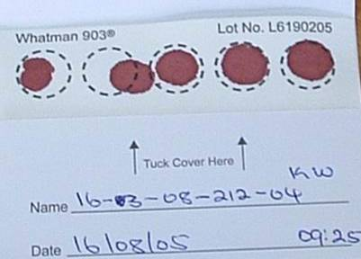

All 5 circles filled. At least 3 are valid.

**Fig2. Invalid DBS card**

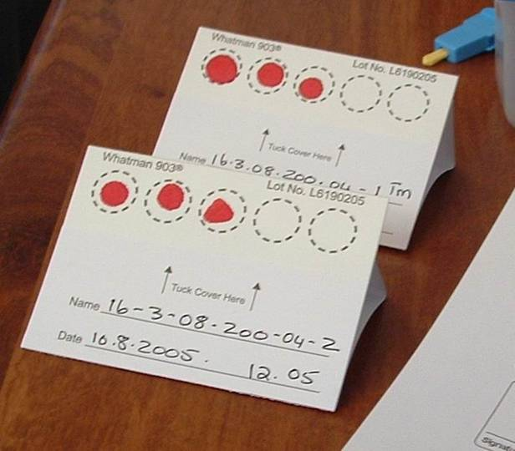

Blood spots are too small

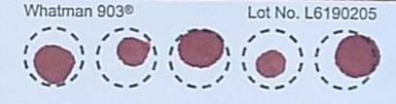

**4** Circles not filled

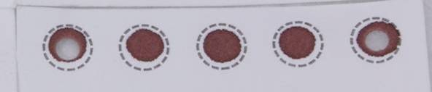

4.2**.** Blood has clotted

Specimen has clotted and appears layered

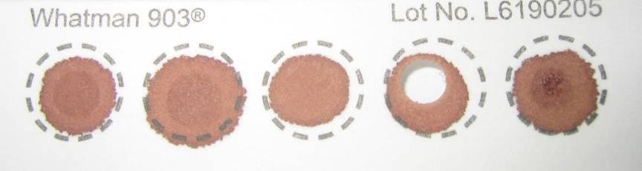

1. If the blood stops flowing before sufficient blood has been collected, gently massage the hand to encourage blood droplets formation. **DO NOT MILK THE FINGER** (i.e. do not squeeze or massage the finger area).

If necessary, a second finger can be cleaned and punctured using a new lancet to obtain adequate sample. It is important that adequate sample is collected; you must saturate each circle with blood.

1. If you are unable to obtain flowing blood using the finger stick despite multiple attempts, please inform the head nurse, clinician or in-charge.
2. After adequate sample is collected, give the participant gauze or swab to hold pressure to the fingertip. Elevate the fingertip above the elbow. After a matter of seconds or minutes, the bleeding should stop. No strapping, plaster, or band-aid is needed.

**3a. Handling specimen after collection in the CLINIC**

This section describes the procedure for handling a collected DBS specimen in the clinic.

1. After completing the sample collection, place the DBS card on the drying rack (Fig 3). The drying rack should ideally be placed so that the DBS cards dry in the horizontal position.
2. If no drying rack is available, the DBS card can be laid flat on a clean paper towel.
3. Fill out the clinic’s lab requisition form and leave it close to the DBS card, so it can accompany the card to the lab, once dry.

**Fig 3. DBS on drying rack**

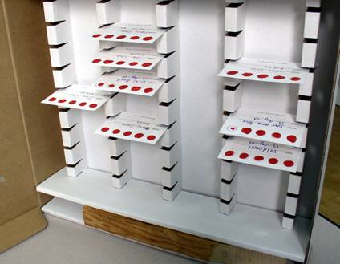

PRECAUTIONS WHEN DRYING THE DBS CARDS:

* Do not touch or smear the blood spots
* Keep away from direct sun-light, dust, and insects
* Do not heat, stack or allow DBS to touch anything during the drying process (including other DBS cards)

1. DBS cards must dry for at least 4 hours (though preferably overnight) prior to being placed in plastic bags and transported to the lab. **DO NOT USE AN EXTERNAL HEAT SOURCE TO DRY DBS.**
2. When dry, the spots will appear a uniform dark brown. The appearance should be similar to that of a dried bloodstain and no areas of red coloration should be seen.

**3b. Handling specimen after collection in the FIELD (outside of clinic) using a transport box**

This section describes the procedure for handling a collected DBS specimen in the field (outside of clinic).

1. Follow the procedure above for collecting DBS (2.1-2.16).

1. Allow the DBS card to dry sufficiently so blood is not flowing when placed in a transport box
2. Appropriately place the DBS card horizontally in a rack already provided in the transport box
3. The transport box must be carried horizontally at all times. **PROTECT YOUR DBS CARD FROM ANY DUST OR DIRECT SUNLIGHT AT ALL TIMES.**

1. When you return to the facility at the end of your tracing activities, ensure that each DBS card has had a lab requisition form filled out
2. When you arrive at the facility, remove the DBS card and leave to air dry effectively for 4 hours or till the next morning. If no drying rack is available at the facility, the DBS card can be laid flat on a clean paper towel.

1. Fill out the facility’s lab requisition form and leave it close to the DBS card, so it can accompany the card to the lab, once dry. Ensure the first two copies of the lab requisition accompany the DBS card to the lab. Retain the third copy and hand this to the person responsible for tracking lab requisition forms and samples to be sent to the reference laboratory.

**4. Packaging of DBS**

Packaging of the DBS is very important. DBS cannot be kept and/or transported at ambient temperature for longer than 14 days. If VL testing cannot be performed within 14 days from the date of collection, DBS should be transported to a central facility where there is a constant electricity supply and a -70°C freeze.

The manner in which they are packaged may determine the quality of the results in the future.

1. Once the DBS card is **COMPLETELY DRY**, place the card in a gas-impermeable zip-locked plastic bag with 1 desiccant pack.
2. Humidity causes damage to the HIV virus particles and should be avoided through use of desiccant and humidity cards.
3. The participant information should be visible through the bag. Make sure the humidity card is placed in the rear of the card facing out so that we can read the card and so that it does not obscure the view of the participant information on the card.
4. Keep the DBS card sealed in its bag from now to when it is ready to be tested. Gently apply pressure to the partially sealed bag to expel the air before sealing completely.
5. Bring the plastic bag containing the DBS along with the lab requisition form to the appropriate area in the clinic so that it can be transported to the national reference laboratory. **DO NOT STAPLE THE REQUISITION FORM TO THE PLASTIC BAG** as this will puncture the bag and allow air to enter.
6. Insert DBS bag into envelope. Place lab requisitions and specimen delivery checklist into envelope. Seal envelope. Label envelope clearly (“[insert Facility Name & Location] ART DBS specimens”). Send to testing lab at Kalingalinga.

_______________________________________________________________________

**PROCEDURES FOR NEEDLE STICK INJURY**

Purpose

The purpose of this section is to define procedures to follow when any staff member suffers a needle stick injury or blood contamination. This procedure applies to all staff involved in collection of blood specimens from Community ART participants.

Responsibilities

The staff members delegated to collect DBS specimens are responsible for understanding and following this section of the SOP.

The staff supervisor is responsible for ensuring that staff knows what action to take when one has a needle stick injury or is exposed to contaminated body fluids when handling and discarding used lancets, broken specimen containers or hazardous waste. In the event of a needle stick injury, it is important to receive all necessary medical attention as directed by the medical officer.

The staff supervisor has ultimate responsibility for ensuring that all applicable FastTrack staff members follow this SOP and that needle stick injuries are appropriately handled.

Appendices

Standard Operating Procedure: Management of Occupational Exposures to potentially Infectious Substances

**Procedures**

Clinic staff are to follow the following steps in case of needle stick injury and skin exposure while working with a patient with known HIV infection.

1. Immediately wash the site with soap and running water. Antiseptics such as alcohol or chlorhexidine can be used on small wounds and puncture sites – these agents have some virucidal activity. DO NOT USE BLEACH or other caustic agents to clean the exposure site or squeeze the wound.
2. In case of mucosal exposure, the exposed surface should be flushed with numerous amount of saline or water.
3. In case of exposure to the eye, immediately flush with copious amounts of clean water
4. Contact on site or nearby head nurse, clinician, In-Charge, or supervisor.
5. The individual with potential HIV exposure should present her/himself nearby health facility for immediate HIV counseling and testing. These results should be made available to health providers during discussions about post-exposure prophylaxis (see below). Should the HIV result be negative, the staff member should follow-up with a repeat test after 3 months.
6. The individual with potential HIV exposure should be referred to a service provider for post-exposure prophylaxis according to the organization’s medical policy (see Appendix).

## **14.0 Dried Blood Spot (DBS) Viral Load Log Book**

**Dried Blood Spot (DBS) Viral Load Log Book**

**Clinic Name:** _______________________________________________________

|  |  |  |  |  |
| --- | --- | --- | --- | --- |
| **Date of Specimen Collection**  **(DD/MM/YY)** | **Time of Specimen Collection**  **(HH:MM)** | **ART ID** | **Patient First Name** | **Patient Surname** |
|  |  |  |  |  |
|  |  |  |  |  |
|  |  |  |  |  |
|  |  |  |  |  |
|  |  |  |  |  |
|  |  |  |  |  |
|  |  |  |  |  |
|  |  |  |  |  |
|  |  |  |  |  |
|  |  |  |  |  |
|  |  |  |  |  |
|  |  |  |  |  |
|  |  |  |  |  |
|  |  |  |  |  |
|  |  |  |  |  |
|  |  |  |  |  |
|  |  |  |  |  |